TAG Survivor Shirts
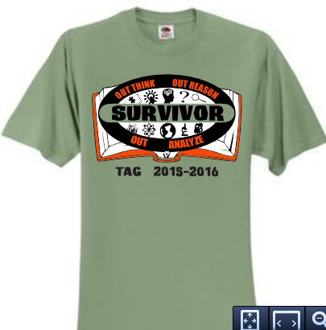
Each T-shirt will be a short sleeve olive green shirt. (You can see the actual color on our tag website.) The design will be large across the front in three colors. Student names will be listed in columns on the back.

Student Name: ________________________________________________________
Deadline to order: September 18, 2015
Please write the number of shirts you would like to purchase in the box next to the appropriate size. Parents may order shirts if they desire. $10 per shirt
 | Youth XS |  |  | Youth S |  |  | Youth M
 | Youth L |  |  | Youth XL |  |  | Adult S
 | Adult M |  |  | Adult L |  |  | Adult XL
 | Adult 2XL  Add $1.50 |  |  | Adult 3XL  Add $2.50 |  |  | Adult 4XL  Add $3.50

Total Shirts Ordered _______________ Amount Paid ______________

